Juan Rodriguez

Communications Assembly Manual

STEP 1: Insert the Swivel Link into the antenna base and check for tight fit.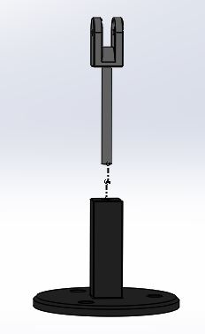

STEP 2: Align the holes of the antenna support, the crossbar and then swivel link. Insert pin a.

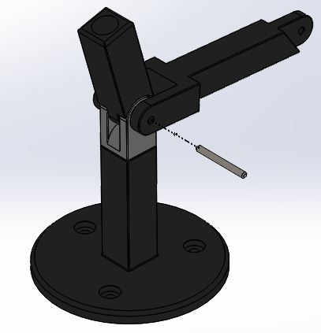

STEP 3: Align the holes of the crossbar and the signal bar. Insert pin b.

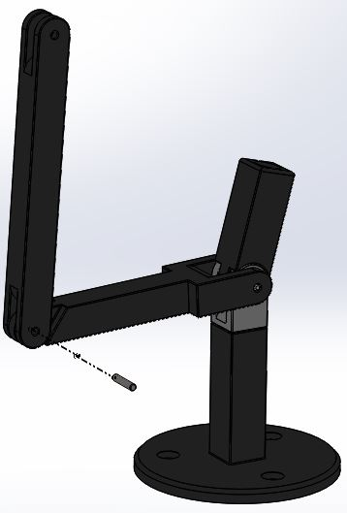

STEP 4: Align the holes of the signal bar and the retriever. Insert the second pin b.

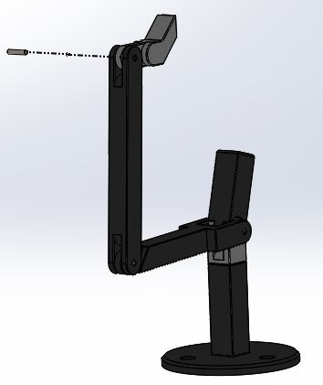

STEP 5: Attach the ball and socket joint to existing assembly.

